V5 LOGISTICS AND WAREHOUSING
Transportation Network & Transit-Time Optimization
Assessment of a Proposed Kolhapur Mini-Hub Against the Existing Bhiwandi-Centred Network
Bhiwandi–Kolhapur Mini-Hub Assessment
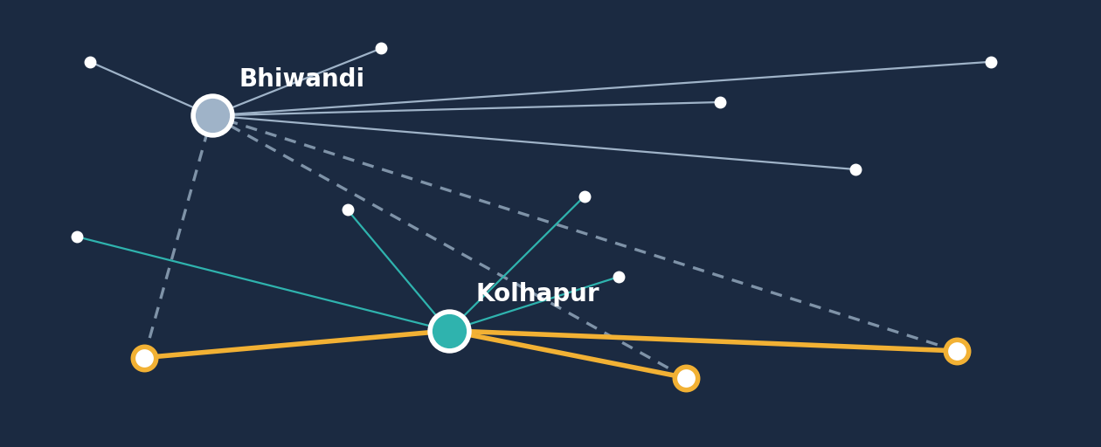

Prepared by: Mahir Valani, Part-time Intern, V5 Logistics and Warehousing

Contents
1 Executive Summary and Dashboard
2 Business Problem and Objectives
3 Methodology
4 Primary Transportation Analysis
5 Secondary Transportation Analysis
6 Proposed Hub Allocation
7 Combined Primary and Secondary Analysis
8 Conservative Planning Scenarios
9 Operational Interpretation
10 KPI Dashboard and Implementation Plan
11 Risk Register
12 Data Limitations and Next Steps
13 Final Conclusion
Appendix A Formulas and Worked Examples
Appendix B Detailed Route Calculations
Appendix C Data-Quality and Reconciliation Notes

Evidence labels used in this report
Every figure is tagged by type so readers can see how far it can be relied on:
• Source-recorded: route estimates taken from V5 route notes and Google Maps.
• Calculated: differences and percentages computed by the analyst from source figures.
• Illustrative scenario: analyst-selected planning assumptions (30%, 35%, 40%).
• Requires validation: recommendations that need operational data before they can be relied on.

1 Executive Summary
Management decision
Adopt a selective two-hub structure on a pilot basis; do not replace Bhiwandi. Serve Sangli, Satara, Karad, Ratnagiri, Sindhudurg, Latur, Dharashiv and Solapur from a Kolhapur mini-hub, flag Nanded for validation, and keep Pune, Ahilyanagar, Parbhani, Amravati, Akola, Nagpur, Nashik and Raigad with Bhiwandi. Confirm the gain with actual trip records before scaling.

The problem
V5 runs its Maharashtra network from Bhiwandi. For destinations in the south and south-west of Maharashtra, and for freight from Goa, Bengaluru and Chennai, Bhiwandi can mean long road legs. Management asked whether a mini-hub in Kolhapur could serve selected origins and destinations more efficiently.

Why a selective Kolhapur mini-hub was evaluated
Kolhapur lies much closer to Goa, to southern Maharashtra and to the Konkan coast than Bhiwandi does. Rather than test a wholesale replacement, the assessment compared estimated driving times lane by lane and asked where each hub is the better fit.

Key findings
- Primary origins (3): estimated driving time falls from 52h 54m to 35h 54m, a saving of 17h 00m or 32.14%. Goa gains most in percentage terms (56.43%), Bengaluru most in time (7h 35m). Chennai gains only 12.33%, and its Kolhapur time is provisional.
- Secondary destinations (8): estimated driving time falls from 60h 18m to 24h 45m, a saving of 35h 33m or 58.96%. Sangli (86.73%), Karad (82.71%) and Sindhudurg (about 68%) lead.
- Combined illustrative comparison: 113h 12m falls to 60h 39m, a saving of 52h 33m or 46.42%. This is an unweighted sum of route estimates, not a network-wide or verified result.
- Conservative planning scenario: because map estimates exclude hub handling, waiting and traffic variation, management should plan around a 30–40% reduction as a hypothesis for discussion, not a forecast.
Audit note on the headline figure
The project brief stated the secondary and combined aggregates as 63.32% and 48.20%, based on totals of 56h 05m / 20h 32m and 108h 59m / 56h 26m. Re-adding the eight route rows gives 60h 18m / 24h 45m and a combined 113h 12m / 60h 39m. The time saved (35h 33m and 52h 33m) is unchanged, but the correct reductions are 58.96% and 46.42%. This report uses the recalculated values (Appendix C).
Key caveats. Figures are mapped driving estimates, not recorded shipment transit. No shipment volumes, frequencies, handling times, on-time records or costs were available. Management implemented the allocation and reported savings, but before-and-after shipment records were not available for this analysis, so no realised improvement is claimed here.

Executive dashboard
3  Primary origins evaluated  Goa, Bengaluru, Chennai | 8  Secondary destinations assessed  Selected for Kolhapur comparison | 46.42%  Combined illustrative reduction  Unweighted aggregate of 11 route comparisons
17h 00m  Primary time saved  32.14% of 52h 54m baseline | 35h 33m  Secondary time saved  58.96% of 60h 18m baseline | 52h 33m  Combined time saved  Of 113h 12m summed baseline

30–40%
Conservative planning range (scenario analysis)
Analyst-selected hypothesis for management discussion. Not observed, not guaranteed.

Figure 1. Aggregate baseline vs proposed estimated driving time
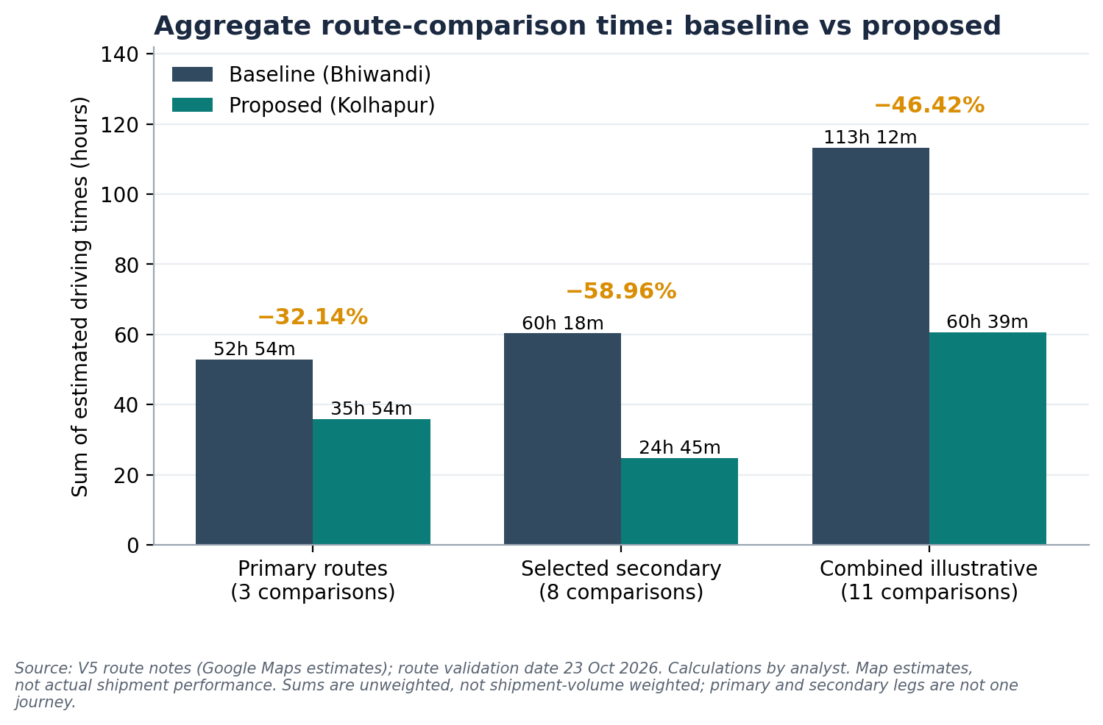
Source: V5 route notes; analyst calculations. Unweighted sums; not shipment-volume weighted. Primary and secondary legs are different network legs, not one journey.
How to read the 46.42% figure
It is a comparative indicator across selected routes. It is not a volume-weighted network result, a verified lead-time reduction, a guarantee, or a measure of total elapsed time including hub processing, loading, unloading or waiting.

2 Business Problem and Objectives
A distribution network built around one central hub is simple to run, but it is not always the most efficient way to serve every destination. Logistics companies reassess hub allocation when a growing share of demand sits far from the hub. The considerations below are general network-design reasoning; the assignment did not measure them at V5 unless stated.
- Excessive road distance. Long legs consume vehicle time and fuel and restrict how many trips a vehicle completes.
- Transit-time variability. Longer routes through congested corridors are more exposed to delay, which affects delivery-window reliability.
- Geographic concentration of destinations. Where many destinations cluster in one region, a nearer facility can serve them with shorter legs.
- Regional consolidation. A regional hub can consolidate loads from several origins before final delivery, which helps only if volumes are sufficient.

Single central hub versus selective two-hub network
Dimension | Single central hub (Bhiwandi only) | Selective two-hub network
Simplicity | One facility, one process | Two facilities, allocation rules to manage
Distance to south and south-west | Long legs for distant destinations | Shorter legs where the second hub is closer
Consolidation | Concentrated volume at one site | Volume split; each hub needs enough throughput
Resilience | Single point of dependency | Backup possible, but only with spare capacity
Handling | Fewer touch points | Possible added handling where freight transfers between hubs

Objective
The objective is not simply to minimise distance. It is to improve transportation efficiency while maintaining service reliability. A shorter map route that adds handling, creates an under-used hub or misses delivery windows would not meet that objective. This assessment screens where a Kolhapur mini-hub looks promising on estimated driving time; it does not yet test service reliability.

3 Methodology
The assessment screens lanes using Google Maps estimates, then uses the results to propose an allocation and a validation plan. Route estimates were reviewed at roughly two to three times of day to reduce dependence on a single reading. The seven steps are:
- Baseline. Treat the existing Bhiwandi-centred network as the comparison baseline.
- Compare. Take the estimated driving time for each selected origin or destination from Bhiwandi and from Kolhapur.
- Difference. Calculate the time saved between the two estimates.
- Percentage. Express the saving as a percentage of the Bhiwandi baseline.
- Classify. Assign each destination to its preferred hub.
- Scenarios. Build conservative and moderate planning scenarios to acknowledge real-world variability.
- Validation data. Identify the operational data needed to verify realised improvements.

Formulas
Measure | Formula
Time saved | Bhiwandi estimated driving time − Kolhapur estimated driving time
Percentage reduction | (Time saved ÷ Bhiwandi estimated driving time) × 100
Aggregate reduction | (Σ baseline route times − Σ proposed route times) ÷ Σ baseline route times × 100

Aggregation caveat. The aggregate adds each listed route's total estimated duration once, so every route comparison carries equal weight in the sense of being counted once. It is not shipment-volume weighted, not frequency weighted, and not a measure of actual end-to-end network lead time.
Data note: working values versus the uploaded report
Route times follow the working values supplied for this analysis. They match the uploaded report for the primary and secondary lanes, with these differences kept visible rather than reconciled:
• Solapur: Bhiwandi estimate of 7h 59m (401 km) comes from a later Google Maps screenshot; the uploaded report held Solapur as pending because no Bhiwandi figure existed. Kolhapur 3h 46m (237 km) is from the uploaded report.
• Nanded and Solapur: the uploaded report listed both as pending validation; the working allocation places both with Kolhapur, with Nanded flagged.
• Chennai–Kolhapur: the uploaded report marks the 20h 09m time as provisional; its online check indicated roughly 13.7–17h. The working value is retained and the conflict is flagged.
• Distances: the uploaded report also records kilometre distances (Appendix C). This report analyses time, so they are not mixed into the calculations.

4 Primary Transportation Analysis
The primary analysis compares Goa, Bengaluru and Chennai as origins routed to Bhiwandi (existing) versus Kolhapur (proposed). All values are source-recorded estimates; differences are calculated.
Origin | Existing route | Bhiwandi time | Proposed route | Kolhapur time | Time saved | Reduction
Goa | Goa–Bhiwandi | 11h 40m (700 min) | Goa–Kolhapur | 5h 05m (305 min) | 6h 35m (395 min) | 56.43%
Bengaluru | Bengaluru–Bhiwandi | 18h 15m (1,095 min) | Bengaluru–Kolhapur | 10h 40m (640 min) | 7h 35m (455 min) | 41.55%
Chennai | Chennai–Bhiwandi | 22h 59m (1,379 min) | Chennai–Kolhapur | 20h 09m (1,209 min) | 2h 50m (170 min) | 12.33%
Total (3) |  | 52h 54m (3,174 min) |  | 35h 54m (2,154 min) | 17h 00m (1,020 min) | 32.14%
Source: V5 route notes (Google Maps estimates). Time saved and reduction are calculated. The aggregate is unweighted and illustrative.
32.14%
Primary aggregate reduction
17h 00m saved of 52h 54m (3 origins, unweighted)

Figure 2. Estimated driving time by origin, Bhiwandi vs Kolhapur
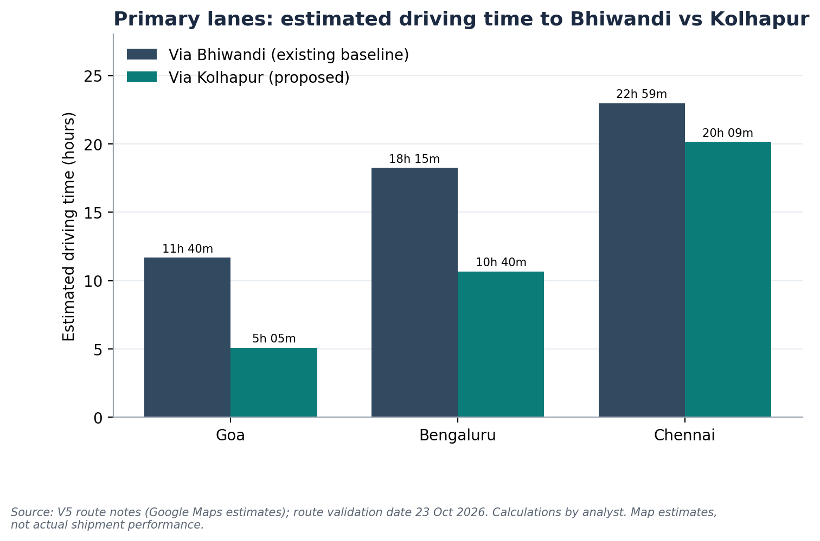
Source: V5 route notes; Google Maps estimates, route validation date 23 Oct 2026.
Figure 3. Estimated driving time saved by origin
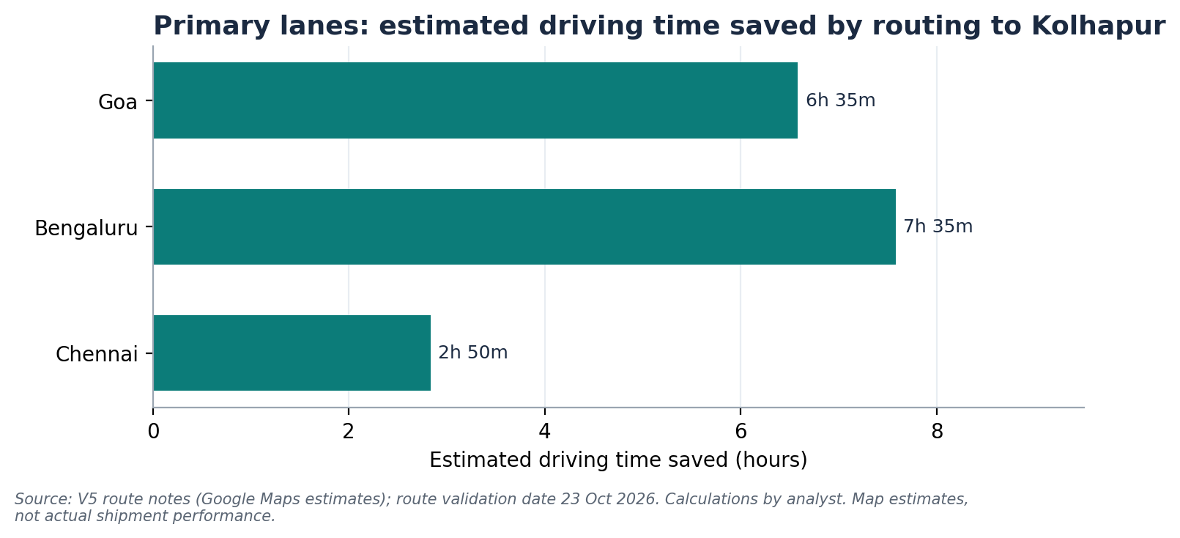
Calculated: Bhiwandi estimate minus Kolhapur estimate.
Figure 4. Percentage reduction against the Bhiwandi baseline
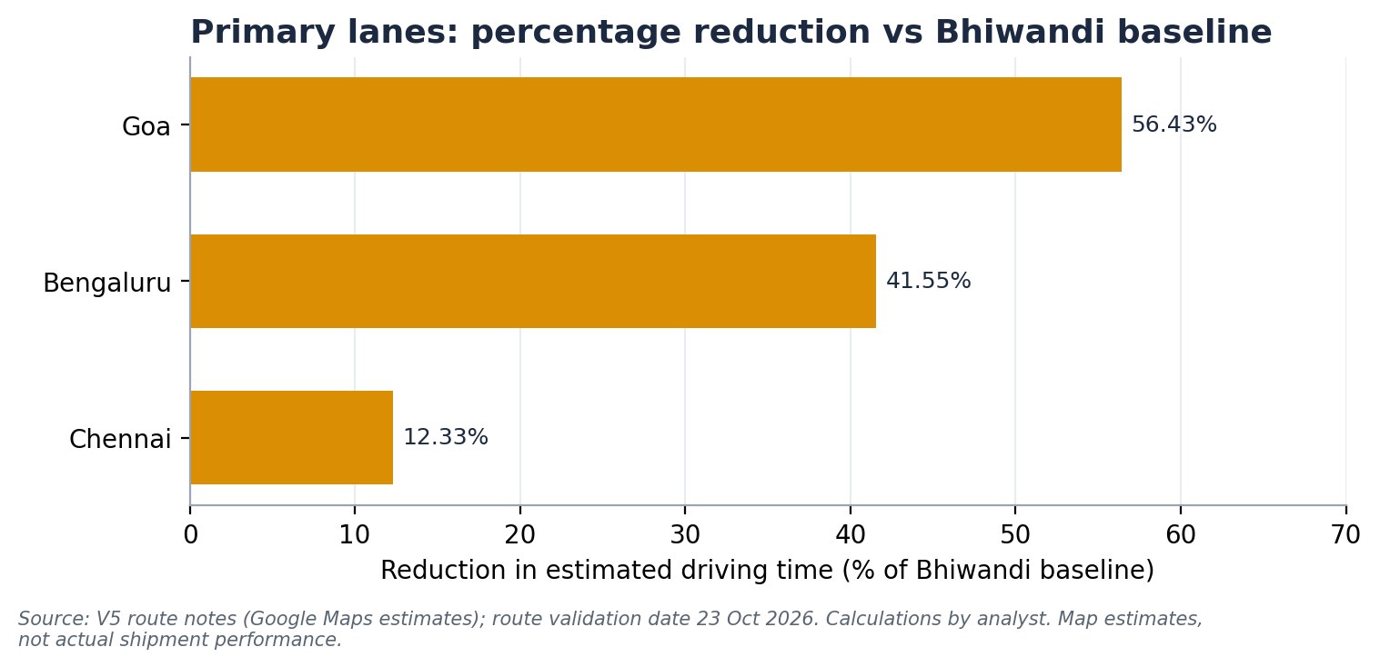
Calculated: time saved ÷ Bhiwandi estimate × 100.

Interpretation
- Goa shows the strongest percentage gain (56.43%), consistent with Kolhapur's position between Goa and the Maharashtra interior.
- Bengaluru delivers the largest absolute time saving (7h 35m).
- Chennai gains only 12.33% because the lane is long either way. Its Kolhapur time is provisional, and the uploaded report's online check pointed to a shorter time, so this lane should be re-verified before it carries weight in the decision.
- Onward leg not captured. Freight from Bengaluru or Chennai bound for destinations best served from Bhiwandi would need onward handling from Kolhapur, which a simple source-to-hub comparison does not include. The uploaded report records a Bhiwandi–Kolhapur leg of 408 km and 8h 15m, which was not analysed here.

5 Secondary Transportation Analysis
Eight destinations were assessed for Kolhapur against the Bhiwandi baseline. Approximate source values (~) are preserved. Each route compares Bhiwandi to destination with Kolhapur to destination.
Destination | Bhiwandi | Kolhapur | Time saved | Reduction | Preferred hub | Data flag
Satara | 5h 18m (318) | 2h 08m (128) | 3h 10m | 59.75% | Kolhapur | Source-recorded
Sangli | 7h 32m (452) | 1h 00m (60) | 6h 32m | 86.73% | Kolhapur | Source-recorded
Karad | 6h 16m (376) | 1h 05m (65) | 5h 11m | 82.71% | Kolhapur | Source-recorded
Latur | 8h 48m (528) | 5h 46m (346) | 3h 02m | 34.47% | Kolhapur | Source-recorded
Sindhudurg | 9h 25m (565) | ~3h 00m (180) | ~6h 25m | ~68.14% | Kolhapur | Kolhapur time approx.
Ratnagiri | ~7h 00m (420) | ~3h 00m (180) | ~4h 00m | ~57.14% | Kolhapur | Both approx.
Dharashiv | ~8h 00m (480) | ~5h 00m (300) | ~3h 00m | ~37.50% | Kolhapur | Both approx.
Solapur | 7h 59m (479) | 3h 46m (226) | 4h 13m | 52.82% | Kolhapur | Preliminary; validate
Total (8) | 60h 18m (3,618) | 24h 45m (1,485) | 35h 33m (2,133) | 58.96%
Minutes in brackets. Solapur Bhiwandi estimate (7h 59m, 401 km) is from a later Google Maps screenshot; Kolhapur estimate (3h 46m, 237 km) is from the uploaded report. Aggregate is unweighted and illustrative. Totals were recalculated; see Appendix C.
58.96%
Secondary aggregate reduction
35h 33m saved of 60h 18m (8 destinations, unweighted)

Figure 5. Estimated driving time by destination, Bhiwandi vs Kolhapur
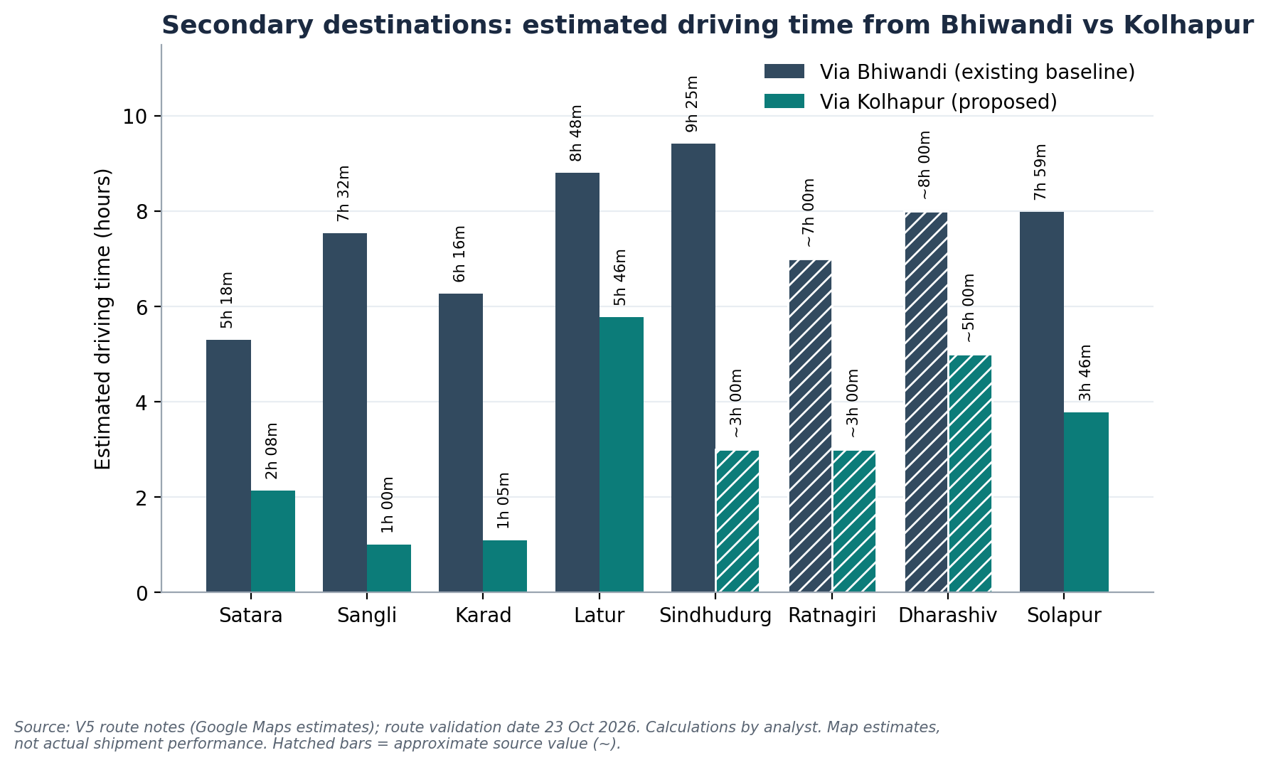
Figure 6. Estimated driving time saved by destination
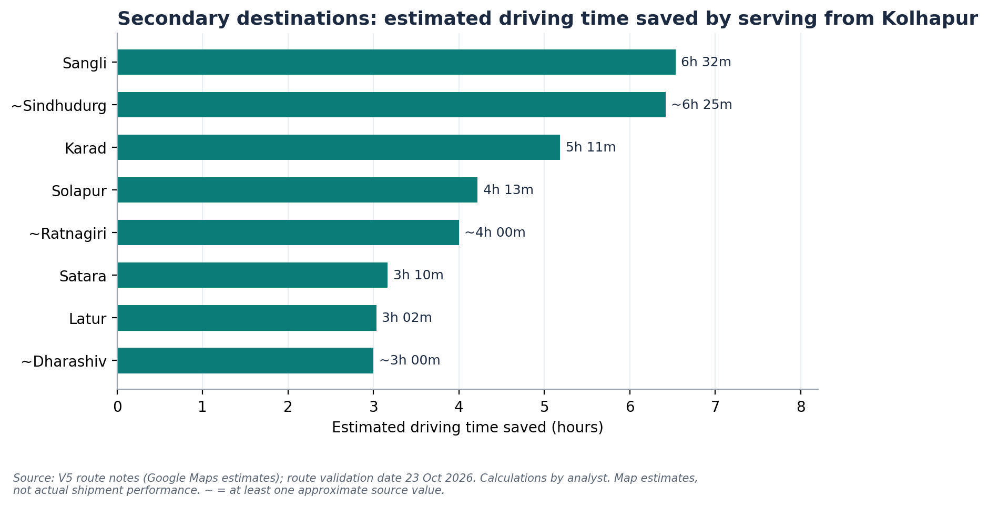
Calculated from source estimates. ~ = approximate source value.
Figure 7. Destinations ranked by percentage reduction
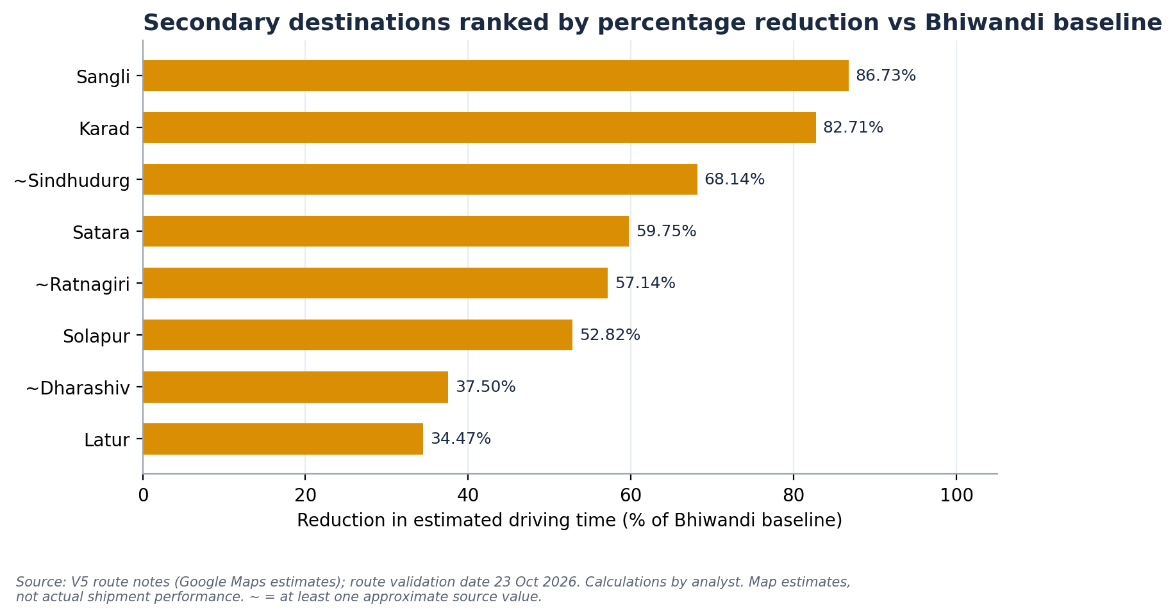
Percentages measure relative gain on each lane; they do not reflect shipment volume.

Route-allocation matrix: Kolhapur and Bhiwandi catchments
Hub | Destination | Bhiwandi time | Kolhapur time | Evidence
Kolhapur | Sangli, Satara, Karad | 7h 32m / 5h 18m / 6h 16m | 1h 00m / 2h 08m / 1h 05m | Clear advantage, source-recorded
Kolhapur | Sindhudurg, Ratnagiri | 9h 25m / ~7h 00m | ~3h 00m / ~3h 00m | Large advantage, approximate
Kolhapur | Latur, Solapur | 8h 48m / 7h 59m | 5h 46m / 3h 46m | Moderate–large; Solapur preliminary
Kolhapur | Dharashiv | ~8h 00m | ~5h 00m | Moderate, approximate
Kolhapur (validate) | Nanded | ~9h | ~9h | Similar times; not a proven improvement
Bhiwandi | Pune | 3h 30m | ~4h | Source-recorded; Bhiwandi closer
Bhiwandi | Ahilyanagar, Parbhani | ~5h / ~7h | ~6h / ~9h | Source-recorded, approximate
Bhiwandi | Amravati, Akola | ~8h / ~6h | ~13h / ~12h | Source-recorded, approximate; Bhiwandi clearly closer
Bhiwandi | Nagpur, Nashik, Raigad | Not compared | Not compared | No route pair recorded; existing allocation kept
Bhiwandi-catchment times are taken from the uploaded report as source-recorded context and were not part of the working calculation set. Nanded is shown with Kolhapur per the working allocation but flagged for validation.

6 Proposed Hub Allocation
Hub | Destinations | Status
Kolhapur (proposed mini-hub) | Sangli, Satara, Karad, Ratnagiri, Sindhudurg, Latur, Nanded, Dharashiv, Solapur | Working recommendation. Nanded flagged for validation; Solapur preliminary.
Bhiwandi (existing hub) | Pune, Ahilyanagar, Parbhani, Amravati, Akola, Nagpur, Nashik, Raigad | Retained; closer on recorded estimates, or no comparison recorded.

Nanded has similar estimated driving times from both hubs (about 9h each in the uploaded report). It should be validated operationally rather than described as a proven transit-time improvement.
Solapur now has a preliminary comparison using the supplied screenshot and the recorded Kolhapur estimate. A final like-for-like route validation remains advisable.
What this allocation is and is not
It is a working recommendation based on mapped estimates. It is not a mathematically optimised network solution. Shipment volumes, service commitments, hub capacity, dispatch schedules and handling times were not available.

Figure 8. Network schematic: hub allocation and primary origins
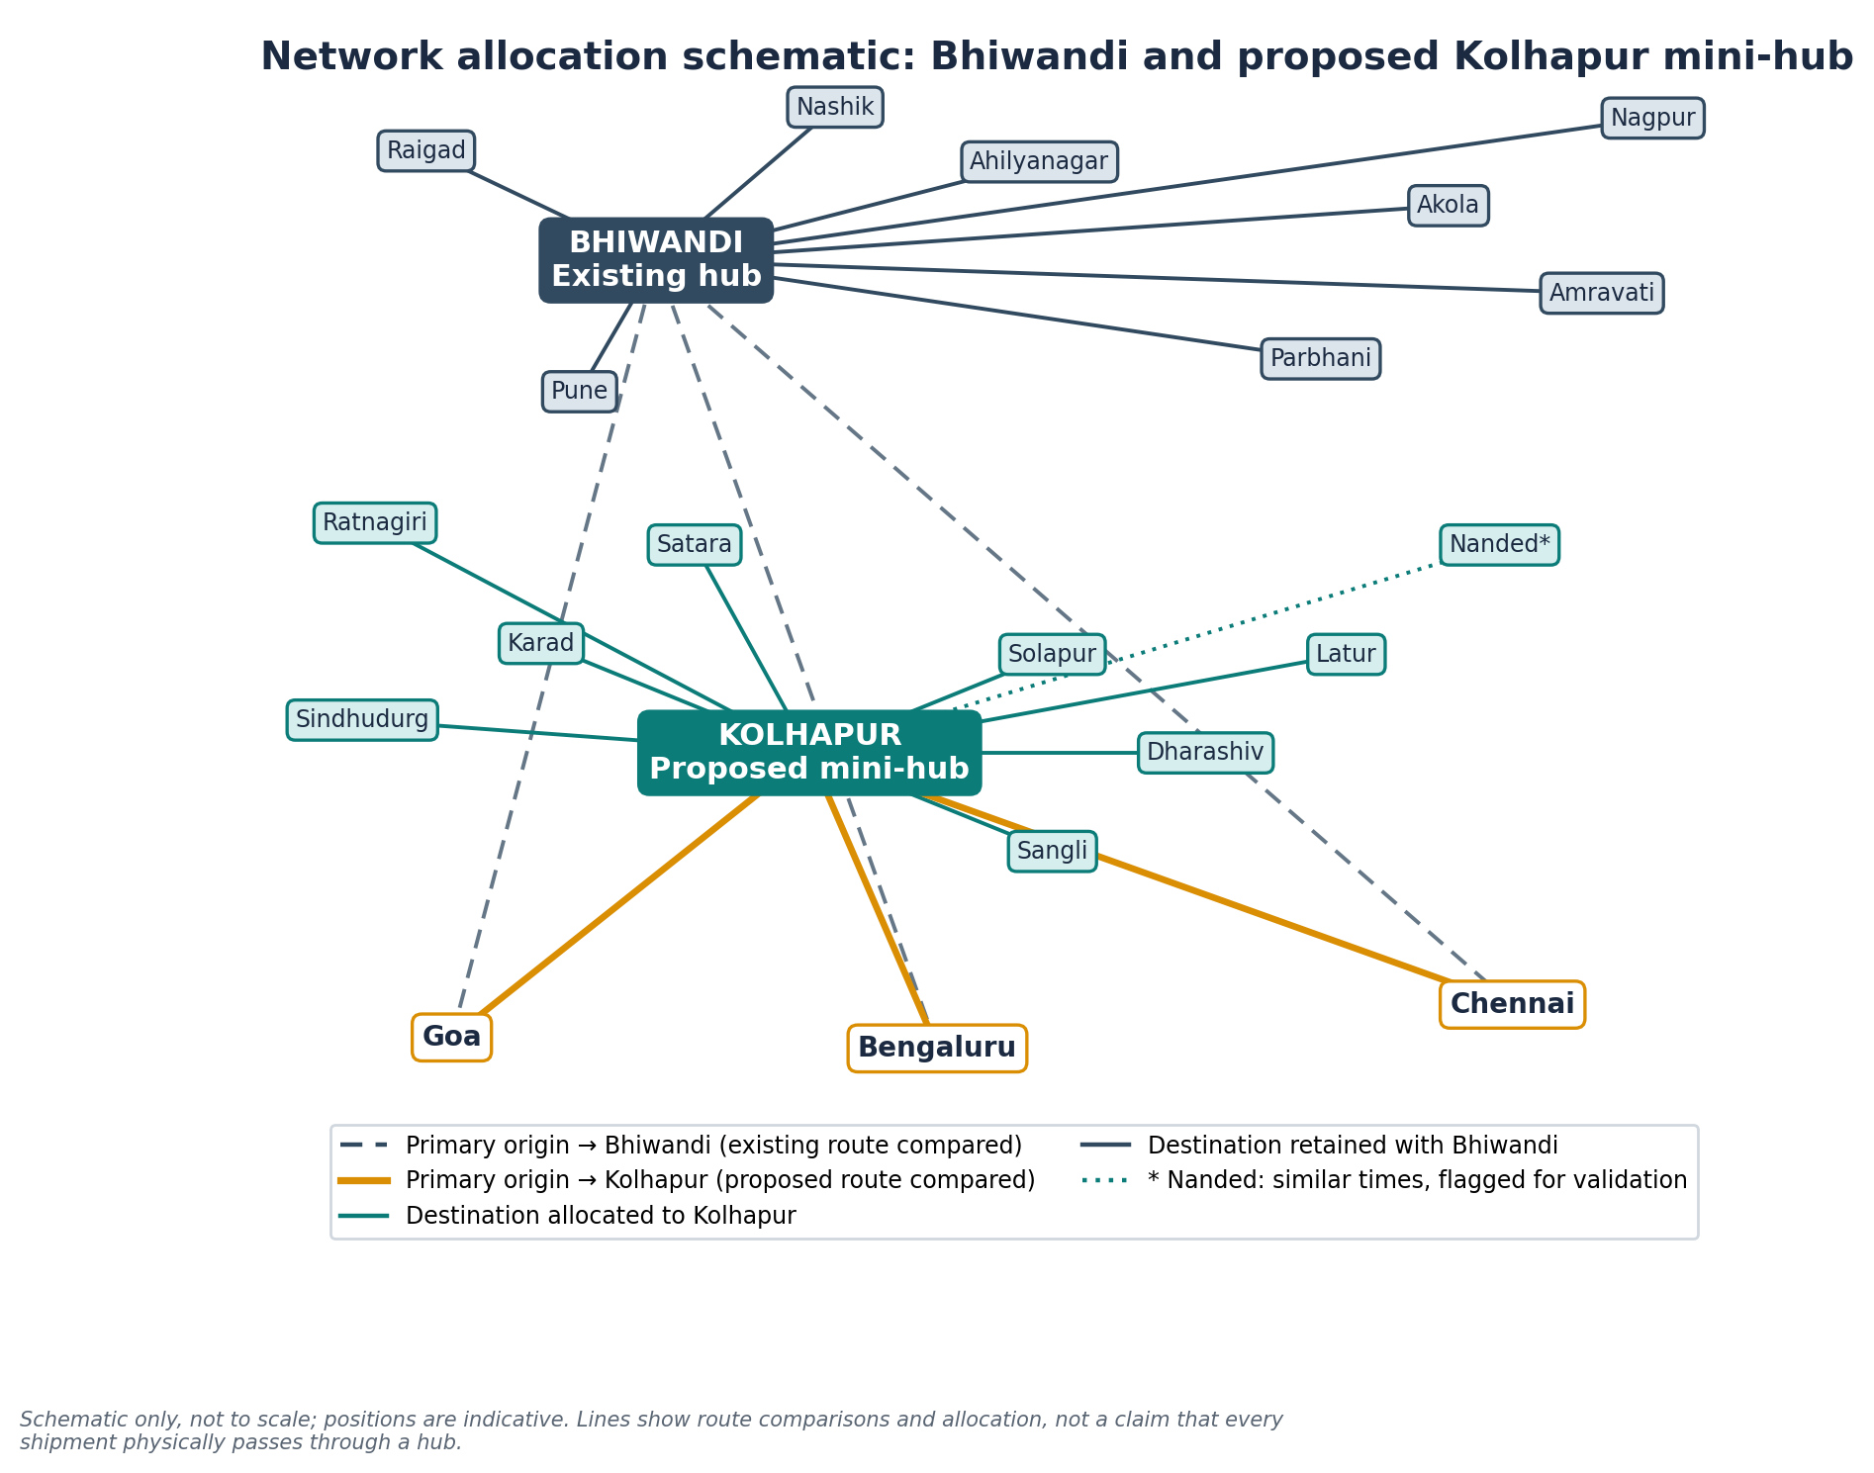
Schematic only; not to scale. Lines show route comparisons and allocation, not a claim that every shipment physically passes through a hub. * Nanded flagged for validation.

7 Combined Primary and Secondary Analysis
Category | Baseline | Proposed | Time saved | Reduction
Primary routes (3) | 52h 54m | 35h 54m | 17h 00m | 32.14%
Selected secondary destinations (8) | 60h 18m | 24h 45m | 35h 33m | 58.96%
Combined illustrative comparisons (11) | 113h 12m | 60h 39m | 52h 33m | 46.42%
Calculated from source estimates. Totals independently recomputed; they differ from the briefing's 56h 05m / 20h 32m (secondary) and 108h 59m / 56h 26m (combined). Time saved agrees. See Appendix C.
What the 46.42% result is, and is not
It is calculated by summing estimated driving times across the selected primary and secondary route comparisons. It is a useful comparative indicator for this analysis. It is not:
• a volume-weighted network-wide result;
• a verified reduction in actual shipment lead time;
• a guaranteed operational improvement;
• evidence that every shipment experiences the same reduction;
• a measurement of elapsed time including hub processing, loading, unloading or waiting.
The primary and secondary comparisons are different network legs. They must not be added and read as one shipment's journey. The result is best described as a combined illustrative route-comparison index.

8 Conservative Planning Scenarios
Real-world performance can differ from map estimates because of traffic variation, route choice, road conditions and diversions, dispatch timing, loading and unloading, hub handling and waiting, vehicle availability, and delivery-window constraints. No measured traffic adjustment is available, so none is asserted. Instead, three explicit scenarios are used.
Scenario | Assumed reduction | Illustrative time saved* | Interpretation
Conservative | 30% | ≈ 33h 58m | Analyst-selected planning assumption for a cautious operational case
Moderate | 35% | ≈ 39h 37m | Analyst-selected intermediate planning assumption
Upper planning hypothesis | 40% | ≈ 45h 17m | Analyst-selected upper end of the 30–40% discussion range
Route-estimate case | 46.42% | 52h 33m | Current illustrative aggregate calculation
*Scenario % × 113h 12m summed combined baseline. 30%, 35% and 40% are analyst-selected scenarios, not observed outcomes or statistically validated confidence bounds.
Figure 9. Sensitivity of the aggregate reduction to planning assumptions
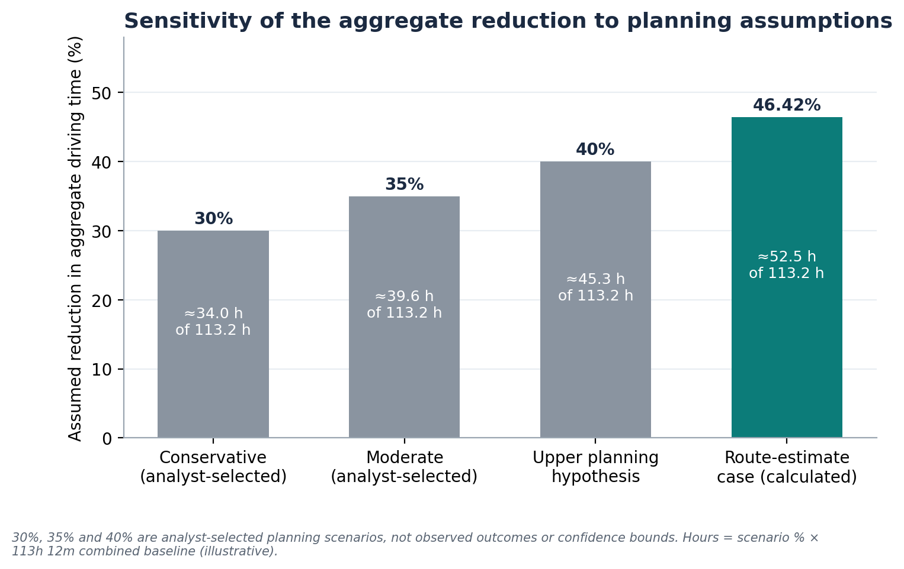
A 30–40% reduction can serve as a planning hypothesis for management discussion. It must not be described as guaranteed or empirically verified.

Three different measures of time
Measure | What it captures | Available here?
1. Map-estimated driving time | Google Maps estimate of driving time for a route at a point in time | Yes (source-recorded)
2. Actual vehicle transit time | Real dispatch-to-arrival time, including traffic, stops and route choice | No
3. End-to-end shipment lead time | Order to delivery, including loading, hub handling, waiting, dispatch schedule and unloading | No
This report works at level 1. Levels 2 and 3 need operating records (Section 12).

9 Operational Interpretation
A selective two-hub network can beat routing everything through Bhiwandi where a second hub sits nearer a cluster of destinations. That benefit is conditional. The factors below decide whether mapped savings survive in operation; none were measured in this assessment.
Factor | Why it matters for the Kolhapur decision
Geographic proximity | Where Kolhapur is much closer (Sangli, Karad, Sindhudurg), shorter legs are likely; where Bhiwandi is closer (Pune, Amravati, Akola), keep Bhiwandi.
Regional consolidation | Feeder legs help only if loads from several origins are consolidated efficiently.
Vehicle availability | Third-party vendors must be available on new lanes, including return loads.
Shipment density | A second hub needs sufficient throughput; low density raises cost per shipment.
Hub capacity | Kolhapur must absorb inbound volume and peaks without queuing.
Dispatch frequency | Infrequent departures can erase driving-time gains through waiting.
Handling and waiting time | Unloading, sorting and reloading add time that may offset distance savings.
On-time delivery and delivery windows | Service compliance is the real test; map time alone does not show it.
Vendor availability and route reliability | Reliable capacity and predictable routes matter as much as nominal speed.
Backup capacity at Bhiwandi | Bhiwandi should remain a fallback if Kolhapur is congested or disrupted.
Risk of an under-used second hub | Without enough throughput, a second hub adds fixed cost and complexity without proportional benefit.

Hub-and-spoke versus cross-docking
In a hub-and-spoke model, freight is routed through a hub, where it may be consolidated, sorted or held before onward dispatch. Cross-docking is a narrower process in which inbound freight is transferred to outbound vehicles with little or no storage. The Kolhapur facility should not be labelled a cross-dock unless its actual operating process confirms rapid transfer without storage. This report uses the broader term mini-hub.
No quantified transit-time savings are claimed as delivered by the allocation. Management reported savings after implementation, but the shipment-level records behind that were not available for this analysis.

10 KPI Dashboard and Implementation Plan
The KPIs below are recommended for post-implementation monitoring. They are not metrics measured during the assignment, and no targets are set because they should be agreed from a verified company baseline.
KPI | Formula or definition
Actual transit time by lane | Arrival timestamp − dispatch timestamp
Estimated-versus-actual variance | Actual transit time − mapped estimate
On-time delivery % | On-time deliveries ÷ total deliveries × 100
On-time in-full (OTIF) % | On-time, complete deliveries ÷ applicable total deliveries × 100
Hub turnaround time | Vehicle exit timestamp − entry timestamp
Hub dwell time | Shipment departure from hub − arrival at hub
Actual distance per trip | Actual kilometres per completed trip
Destination-level route performance | Actual time and distance against the alternative hub
Route compliance % | Trips following the approved route ÷ total trips × 100
Route validation coverage % | Validated active lanes ÷ total active lanes × 100

Phased implementation roadmap
The phases are a recommended sequence. No dates are proposed, and none of the phases is claimed to have occurred.
Phase | Activity | Output
1 | Validate all route distances and travel-time estimates (including Chennai–Kolhapur, Solapur and Nanded) | Validated route master
2 | Establish the baseline using actual trip logs and timestamps | Verified Bhiwandi baseline by lane
3 | Pilot selected Kolhapur routes | Pilot trip records
4 | Compare actual pilot performance with the Bhiwandi baseline | Actual vs baseline variance
5 | Adjust allocations based on service and operational performance | Revised allocation
6 | Review the network periodically as shipment patterns change | Standing review cycle

11 Risk Register
Impact ratings are preliminary qualitative assessments made without company data, not measured risk scores. Likelihood is not rated because no data support it.
Risk | Operational consequence | Impact (prelim.) | Mitigation | Responsible function
Traffic-related variability | Actual transit exceeds mapped estimate; missed windows | Medium | Compare actual vs estimate by lane and time of day; build buffers | Transport operations
Incorrect route estimates | Allocation based on flawed inputs | High | Re-validate every lane in Google Maps; resolve Chennai and Solapur flags | Network planning
Low shipment density at Kolhapur | Under-used hub; high cost per shipment | High | Obtain volumes by lane before scaling; pilot first | Network planning / finance
Additional hub handling | Handling time offsets driving-time gains | High | Measure hub turnaround and dwell time | Hub operations
Vehicle shortages | Delays or cost increases on new lanes | Medium | Confirm vendor capacity and return loads before pilot | Transport operations
Poor load consolidation | Partly empty vehicles; weaker economics | Medium | Track vehicle utilisation; set consolidation rules | Transport operations
Delivery-window failures | Service and customer impact | High | Monitor on-time % and OTIF; keep Bhiwandi fallback | Customer service
Increased operational complexity | Allocation errors; coordination burden | Medium | Documented allocation rules; route compliance tracking | Network planning
Inadequate performance data | Benefits cannot be verified | High | Capture timestamps and trip logs from pilot start | Management / IT
Impact ratings are qualitative and preliminary, not derived from V5 data.

12 Data Limitations and Next Steps
The analysis relies on mapped driving-time estimates. It does not contain:
- Complete actual before-and-after shipment transit records
- Shipment volumes by route
- Trip frequencies
- Verified end-to-end lead times
- Hub processing and waiting times
- Dispatch schedule data
- Actual on-time delivery records
- A volume-weighted network performance baseline
Mapped estimates support initial network screening. Only actual operational records can demonstrate realised improvements.

What management should collect
Data | Purpose
Dispatch and arrival timestamps per trip, by lane, for both hubs | Actual transit time and estimate variance
Shipment volumes and trip frequencies by lane | Volume-weighted comparison; hub throughput test
Hub entry/exit and shipment dwell timestamps | Handling and waiting time
Delivery records against agreed windows (on-time, in-full) | Service reliability
Planned vs actual kilometres per trip | Route compliance and distance
Vehicle and vendor availability by lane | Capacity feasibility
Freight rates and incremental hub costs (finance team) | Net cost evaluation, outside this report's scope

13 Final Conclusion
Management recommendation
A selective Kolhapur mini-hub appears promising for the identified regional destinations because the current route estimates show substantial potential reductions in driving time on several lanes. Bhiwandi should remain operationally important for destinations that continue to favour its location.
Management should validate the route estimates, pilot the selected allocation, and monitor actual transit time, service reliability, hub handling and cost before making broader network decisions.

Appendix A Formulas and Worked Examples
Item | Worked example
Time saved (Goa) | 700 − 305 = 395 min = 6h 35m
Percentage reduction (Goa) | 395 ÷ 700 × 100 = 56.43%
Primary aggregate | (3,174 − 2,154) ÷ 3,174 × 100 = 1,020 ÷ 3,174 = 32.14%
Secondary aggregate | (3,618 − 1,485) ÷ 3,618 × 100 = 2,133 ÷ 3,618 = 58.96%
Combined aggregate | (6,792 − 3,639) ÷ 6,792 × 100 = 3,153 ÷ 6,792 = 46.42%
Scenario hours (30%) | 6,792 min × 0.30 = 2,037.6 min ≈ 33h 58m

Appendix B Detailed Route Calculations

Primary routes (minutes)
Origin | Bhiwandi (min) | Kolhapur (min) | Saved (min) | Saved (h m) | Reduction
Goa | 700 | 305 | 395 | 6h 35m | 56.43%
Bengaluru | 1,095 | 640 | 455 | 7h 35m | 41.55%
Chennai | 1,379 | 1,209 | 170 | 2h 50m | 12.33%
Total | 3,174 | 2,154 | 1,020 | 17h 00m | 32.14%

Secondary destinations (minutes)
Destination | Bhiwandi (min) | Kolhapur (min) | Saved (min) | Saved (h m) | Reduction | Rank
Satara | 318 | 128 | 190 | 3h 10m | 59.75% | 4
Sangli | 452 | 60 | 392 | 6h 32m | 86.73% | 1
Karad | 376 | 65 | 311 | 5h 11m | 82.71% | 2
Latur | 528 | 346 | 182 | 3h 02m | 34.47% | 8
Sindhudurg (~) | 565 | 180 | 385 | ~6h 25m | ~68.14% | 3
Ratnagiri (~) | 420 | 180 | 240 | ~4h 00m | ~57.14% | 5
Dharashiv (~) | 480 | 300 | 180 | ~3h 00m | ~37.50% | 7
Solapur | 479 | 226 | 253 | 4h 13m | 52.82% | 6
Total | 3,618 | 1,485 | 2,133 | 35h 33m | 58.96%
Full formulas are in V5_Transit_Time_Analysis.xlsx. (~) marks approximate source values.

Appendix C Data-Quality and Reconciliation Notes
Item | Brief / source stated | Recalculated or noted
Secondary baseline total | 56h 05m | 60h 18m (sum of eight rows = 3,618 min)
Secondary proposed total | 20h 32m | 24h 45m (sum of eight rows = 1,485 min)
Secondary reduction | 63.32% | 58.96%. Time saved 35h 33m agrees
Combined baseline / proposed | 108h 59m / 56h 26m | 113h 12m / 60h 39m. Time saved 52h 33m agrees
Combined reduction | 48.20% | 46.42%
Chennai–Kolhapur time | 20h 09m (working) | Source marks provisional; online check ~13.7–17h. Conflict preserved
Solapur | Pending in source | Preliminary: Bhiwandi 7h 59m (screenshot), Kolhapur 3h 46m (source)
Nanded | Pending in source | Working allocation: Kolhapur, flagged; similar times (~9h each)

Source distances from the uploaded report (km, Bhiwandi / Kolhapur): Goa 600 / 223, Bengaluru 1,002 / 631, Chennai 1,338 / 937. The source reports a combined 2,940 km versus 1,791 km (39.1%) across three one-way movements. This is a distance measure and is separate from the time analysis in this report. The source also notes that its online checks were against public route-planning sources rather than Google Maps itself, so a final lane-by-lane Google Maps check is recommended.

